**DB Midterm Report**

**Aidyn Nasradin 210103111**

1) For my project, I chose an online store that sells clothes. Everything from shoes and pants to caps and T-shirts. In the project, I have a few triggers and procedures that I will demonstrate to you later.

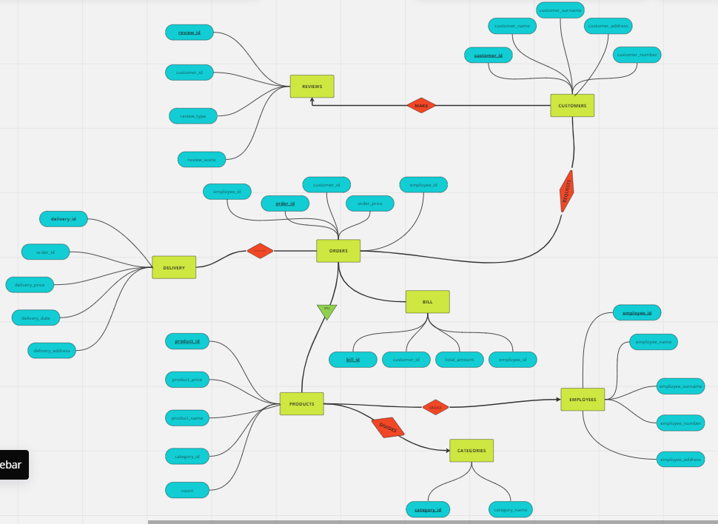

2)Here is my Entity Relation Diagram.

3)Here I will leave the codes that I used to create tables in Oracle Apex.

CREATE TABLE customers (

    customer_id INT PRIMARY KEY,

    customer_name VARCHAR(255),

    customer_surname VARCHAR(255),

    customer_address VARCHAR(255),

    customer_number VARCHAR(255)

);

CREATE TABLE categories (

    category_id INT PRIMARY KEY,

    category_name VARCHAR(255)

);

CREATE TABLE reviews (

    review_id INT PRIMARY KEY,

    customer_id INT,

    review_content VARCHAR(500),

    review_score INT,

    FOREIGN KEY (customer_id) REFERENCES customers (customer_id)

);

CREATE TABLE products (

    product_id INT PRIMARY KEY,

    category_id INT,

    product_price INT,

    product_name VARCHAR(100),

    FOREIGN KEY (category_id) REFERENCES categories (category_id)

);

CREATE TABLE orders (

    customer_id INT,

    order_id INT PRIMARY KEY,

    order_price INT,

    FOREIGN KEY (customer_id) REFERENCES customers (customer_id)

);

CREATE TABLE employees2 (

    employee_id INT PRIMARY KEY,

    employee_name VARCHAR(255),

    employee_surname VARCHAR(255),

    employee_number VARCHAR(255),

    employee_address VARCHAR(255)

);

4)This is the relations between tables:

1. Employee to Product - (Many-to-Many)
2. Orders to Products - (Many-to-Many)
3. Product to Categories - (One-to-Many)
4. Customers to Reviews - (Many-to-One)
5. Customers to Orders - (Many-to-One)
6. Orders to Delivery - (One-to-One)
7. Orders to Bill - (One-to-One)